Angular - Form Validation

Form validation is a process used to check whether the user input is in the correct format or not before submission. The validation process can be used to verify the format of email addresses and phone numbers as they have specific formats. Also, you can verify if the given input meets specific constraints like a minimum or maximum length. The form validation can prevent errors by catching invalid input before it is processed or sent to the server.

Built-in Angular Validators
The Validator class in Angular provides a set of built-in validator functions that validate the form controls. A list of validator functions is:
Validator | Description
min | This validator is used to check whether the control's value is greater than or equal to the specified number.
max | Unlike min, the max validator checks if the control's value is less than or equal to a specified number.
required | When required validator is applied, it checks if the input field has a value and marks the form control as invalid if it is empty. This validator is used in mandatory fields of a form to ensure that users provide the necessary information before submitting the form.
requiredTrue | If applied, it checks whether the value is true. Commonly used for checkbox validation.
email | To make sure the control's value is a valid email address format, the email validator is used.
minLength | It validates that the control's value is at least a specified length.
maxLength | This validator ensures that the control's value does not exceed a specified length.
pattern | It validates that the control's value matches a specified regular expression.
nullValidator | It is a no operation validator that always returns null. Commonly used for validation control.
compose | Combines multiple synchronous validators into one validator function. It returns an error map if any of the individual validators fail.
composeAsync | Similar to compose, but it combines asynchronous validators and returns an observable that emits either null for valid or an error object for invalid.

Official Reference: https://angular.dev/guide/forms/signals/validation

Example - Validation in Angular Template-Driven Forms
In Angular, Template-Driven Forms are forms where the validation is applied directly in the HTML template using Angular's built-in directives, like required, minlength, maxlength, and more. This type of form uses ngModel directive for two-way data binding and needs less code than Reactive Forms.

In the below example, we will see how to use the validation in Template-Driven Form:
- Create a new application app-form-validation. Open with VS Code.
- Open the app.ts file to prepare the code:
import { CommonModule } from '@angular/common';
import { Component, signal } from '@angular/core';
import { FormsModule } from '@angular/forms';
import { RouterOutlet } from '@angular/router';

@Component({
selector: 'app-root',
imports: [RouterOutlet, FormsModule, CommonModule],
templateUrl: './app.html',
styleUrl: './app.css'
})
export class App {
protected readonly title = signal('nestedApplication');
user = {
email: '',
password: ''
};
onSubmit(form: any) {
if (form.valid) {
console.log('Form Submitted!', this.user);
}
}
}
- Open the app.html file and prepare the code:
<form #userForm="ngForm" (ngSubmit)="onSubmit(userForm)">
<div>
<label for="email">Email</label>
<input class="input-box" type="email" id="email" name="email" [(ngModel)]="user.email" required email #email="ngModel">
@if (email.invalid && email.touched) {
<div class="error">
Email is required and must be a valid email address.
</div>
}
</div>

<div>
<label for="password">Password</label>
<input class="input-box" type="password" id="password" name="password" [(ngModel)]="user.password" required minlength="6" #password="ngModel">
@if(password.invalid && password.touched){
<div class="error">
Password is required and must be at least 6 characters long.
</div>
}
</div>

<button class="btn" type="submit" [disabled]="userForm.invalid">Submit</button>
</form>
<router-outlet />
- Open app.css and add the code shown below
.input-box {
margin: 10px;
padding: 5px 15px;
border-color: rgb(103, 220, 181);
}
.btn {
padding: 5px 15px;
color: white;
font-weight: bold;
background-color: rgb(103, 220, 181);
}

p {
font-weight: bold;
margin-top: 10px;
}

.error {
color: red;
font-size: 12px;
}

input.ng-touched.ng-invalid {
border-color: red;
}

input.ng-touched.ng-valid {
border-color: green;
}

button {
margin-top: 10px;
}
- Save all files.
- Now run the application, and try enter some invalid data
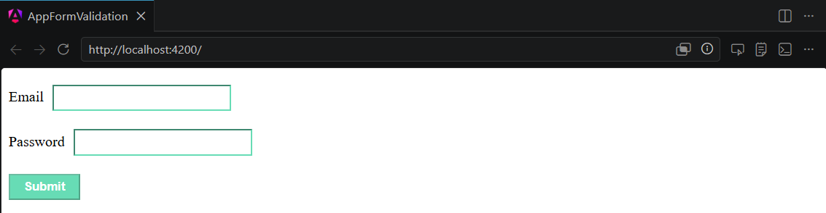

Example - Validation in Angular Reactive Forms
In Angular, Template-Driven Forms are forms where the validation is applied directly in the HTML template using Angular's built-in directives, like required, minlength, maxlength, and more. This type of form uses ngModel directive for two-way data binding and needs less code than Reactive Forms.

In the below example, we will see how to use the validation in Template-Driven Form:
- Create a new application app-reactiveform-validation. Open with VS Code.
- Open the app.ts file to prepare the code:
import { CommonModule } from '@angular/common';
import { Component, signal } from '@angular/core';
import { FormControl, FormGroup, ReactiveFormsModule, Validators } from '@angular/forms';
import { RouterOutlet } from '@angular/router';

@Component({
selector: 'app-root',
imports: [RouterOutlet, ReactiveFormsModule, CommonModule],
templateUrl: './app.html',
styleUrl: './app.css'
})
export class App {
protected readonly title = signal('nestedApplication');
loginForm: FormGroup;

constructor() {
this.loginForm = new FormGroup({
email: new FormControl('', [Validators.required, Validators.email]),
password: new FormControl('', [Validators.required, Validators.minLength(6)]),
});
}

onSubmit() {
if (this.loginForm.valid) {
console.log('Form Submitted!', this.loginForm.value);
} else {
console.log('Form is not valid');
}
}
}
- Open the app.html file and prepare the code:
<form [formGroup]="loginForm" (ngSubmit)="onSubmit()">
<div>
<label for="email">Email</label>
<input class="input-box" type="email" id="email" formControlName="email">
@if(loginForm.controls['email'].invalid && loginForm.controls['email'].touched){
<div class="error">
Email is required and must be a valid email address.
</div>
}
</div>

<div>
<label for="password">Password</label>
<input class="input-box" type="password" id="password" formControlName="password">
@if(loginForm.controls['password'].invalid && loginForm.controls['password'].touched) {
<div class="error">
Password is required and must be at least 6 characters long.
</div>
}
</div>

<button class="btn" type="submit" [disabled]="loginForm.invalid">Submit</button>
</form>

<router-outlet />
- Open app.css and add the code shown below
.input-box {
margin: 10px;
padding: 5px 15px;
border-color: rgb(103, 220, 181);
}
.btn {
padding: 5px 15px;
color: white;
font-weight: bold;
background-color: rgb(103, 220, 181);
}

p {
font-weight: bold;
margin-top: 10px;
}

.error {
color: red;
font-size: 12px;
}

input.ng-touched.ng-invalid {
border-color: red;
}

input.ng-touched.ng-valid {
border-color: green;
}

button {
margin-top: 10px;
}
- Save all files.
- Now run the application, and try enter some invalid data
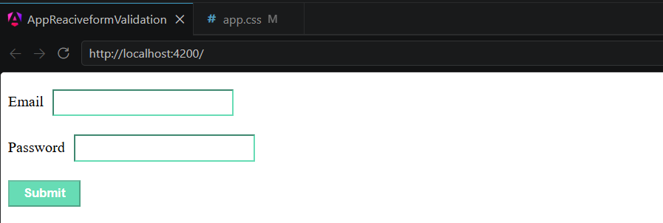

Custom validation rules
While built-in validation rules handle common cases, you'll often need custom validation logic for business rules, complex formats, or domain-specific constraints.

Using validate()
The validate() function creates custom validation rules. It receives a validator function that accesses the field context and returns:
Return Value | Meaning
Error object | Value is invalid
null or undefined | Value is valid

import {Component, signal} from '@angular/core';
import {form, FormField, validate} from '@angular/forms/signals';
@Component({
selector: 'app-url-form',
imports: [FormField],
template: `
<form novalidate>
<label>
Website URL
<input [formField]="urlForm.website" />
</label>
</form>
`,
})
export class UrlFormComponent {
urlModel = signal({website: ''});
urlForm = form(this.urlModel, (schemaPath) => {
validate(schemaPath.website, ({value}) => {
if (!value().startsWith('https://')) {
return {
kind: 'https',
message: 'URL must start with https://',
};
}
return null;
});
});
}
The validator function receives a FieldContext object with:
Property | Type | Description
value | Signal | Signal containing the current field value
state | FieldState | The field state reference
field | FieldTree | The field tree reference
valueOf() | Method | Get the value of another field by path
stateOf() | Method | Get the state of another field by path
fieldTreeOf() | Method | Get the field tree of another field by path
pathKeys | Signal | Path keys from root to current field
NOTE: Child fields also have a key signal, and array item fields have both key and index signals. Refer to official reference for other supported validation methods.

Return an error object with kind and message when validation fails. Return null or undefined when validation passes.

Your Challenge
- Complete the 2 projects
- Build a new application with own form design for testing the validators. (Try as many validators as you can)
- Refer to the custom validation section, and Angular official reference, try to create your own custom validator to test it with your own application.

